**Guide to Dataflow**

As you have been learning, Dataflow is a serverless data-processing service that reads data from the source, transforms it, and writes it in the destination location. Dataflow creates pipelines with open source libraries, with which you can interact using different languages, including Python and SQL. This reading provides information about accessing Dataflow and its functionality.

**Navigate the homepage**

If you completed the optional [Create a Google Cloud account](https://www.coursera.org/learn/the-path-to-insights-data-models-and-pipelines/quiz/Laqpn/optional-activity-create-a-google-cloud-account)  activity, you can follow along with the steps of this reading in your Dataflow console. Go to the [Dataflow Google Cloud](https://cloud.google.com/dataflow) homepage and sign in to your account to access Dataflow. Then click  the **Go to Console** button or the **Console** button. Here, you will be able to create new jobs and access Dataflow tools.

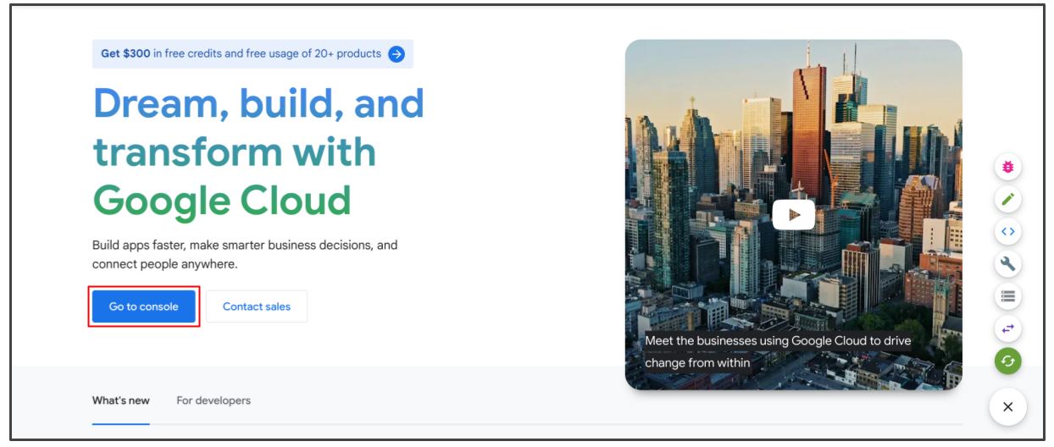

**Jobs**

When you first open the console, you will find the **Jobs** page. The **Jobs** page is where your current jobs are in your project space. There are also options to CREATE JOB FROM TEMPLATE or CREATE MANAGED DATA PIPELINE from this page, so that you can get started on a new project in your Dataflow console. This is where you will go anytime you want to start something new.

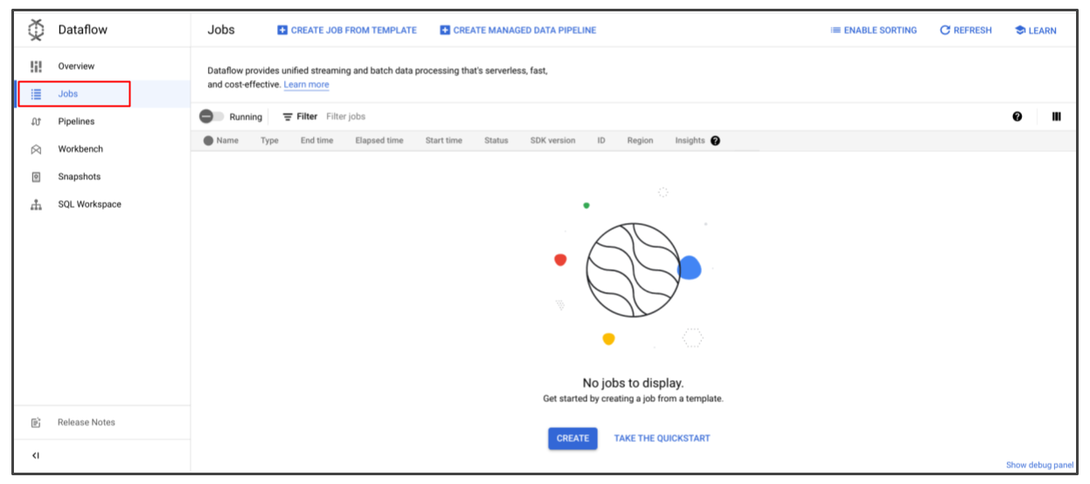

**Pipelines**

Open the menu pane to navigate through the console and find the other pages in Dataflow. The **Pipelines** menu contains a list of all the pipelines you have created. If this is your first time using Dataflow, it will also display the processes you need to enable before you can start building pipelines. If you haven’t already enabled the APIs, click **Fix All** to enable the API features and set your location.

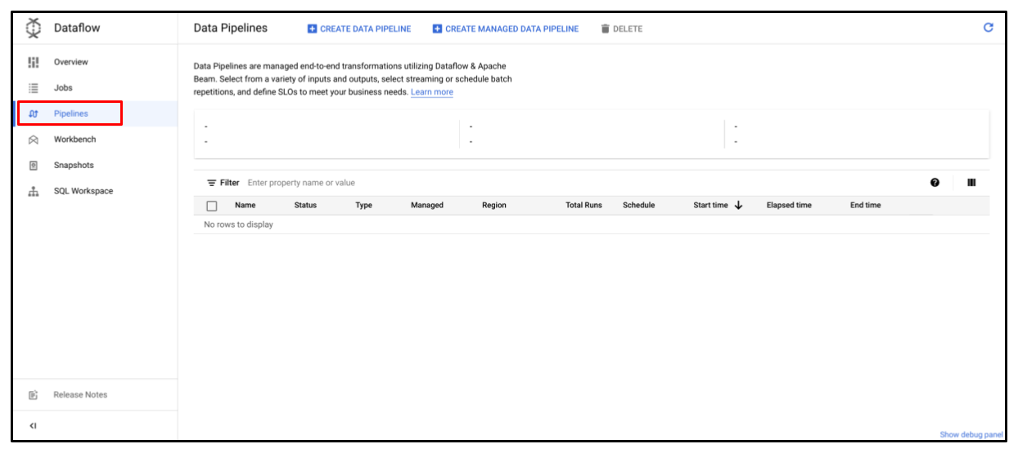

**Workbench**

The **Workbench** section is where you can create and save shareable Jupyter notebooks with live code. This is helpful for first-time ETL tool users to check out examples and visualize the transformations.

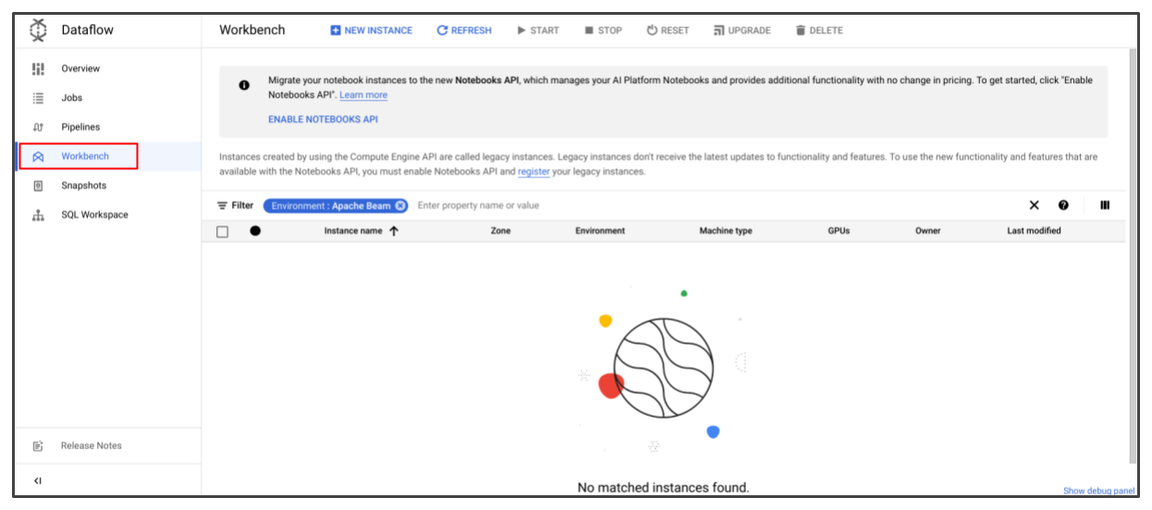

**Snapshots**

**Snapshots** save the current state of a pipeline to create new versions without losing the current state. This is useful when you are testing or updating current pipelines so that you aren’t disrupting the system. This feature also allows you to back up and recover old project versions. You may need to enable APIs to view the **Snapshots** page; you will learn more about APIs in an upcoming activity.

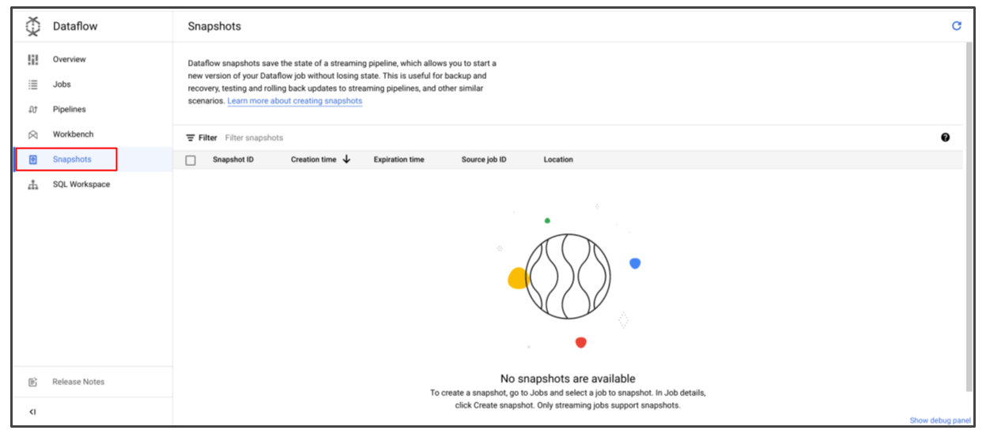

**SQL Workspace**

Finally, the **SQL Workspace** is where you interact with your Dataflow jobs, connect to BigQuery functionality, and write necessary SQL queries for your pipelines.

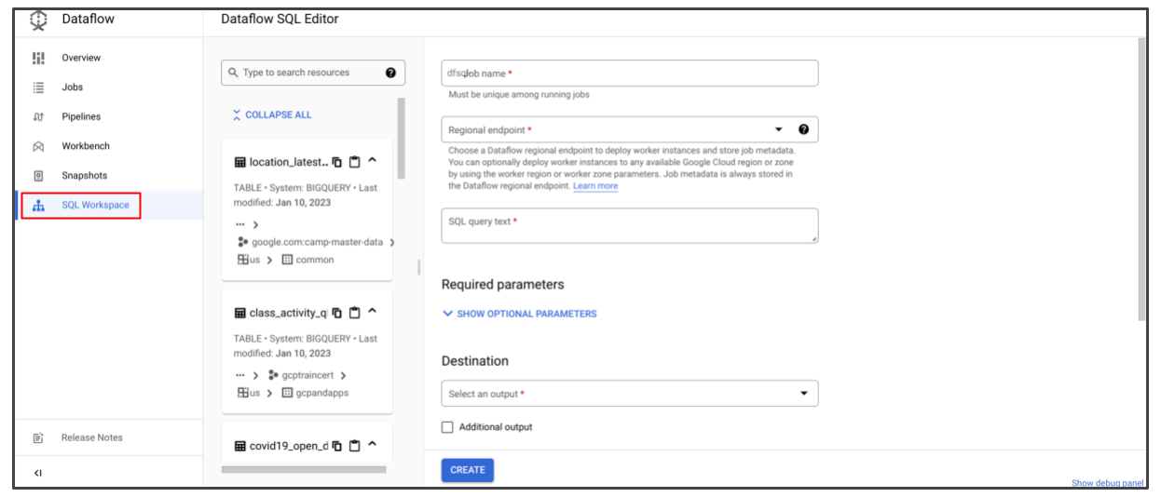

Dataflow also gives you the option to interact with your databases using other coding languages, but you will primarily be using SQL for these courses.

Dataflow is a valuable way to start building pipelines and exercise some of the skills you have been learning in this course. Coming up, you will have more opportunities to work with Dataflow, so now is a great time to get familiar with the interface!